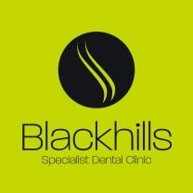

Advice for patients with new crowns and/or bridges

- You should expect the new teeth to initially feel a little strange in your mouth and your tongue may be very aware of the new shapes. This is a normal feeling at this time. The mouth is extremely sensitive to new changes and it usually takes at least 2 weeks to adapt to the new teeth.

- You may also notice that your speech is a little different. Again, this should settle as you adapt to your new teeth. If you have been wearing a temporary denture it may take longer for the tongue to adapt to the new shape and for the speech to fully settle.

- It is absolutely critical that you continue to keep your teeth and mouth extremely clean on a daily basis. This will help the teeth and restorations to last as long as is possible. Please clean around and between your own teeth and the crown/bridge teeth thoroughly twice a day. This may require the use of new brushes or special floss. We might advise a visit to the hygienist to help with this. If you are struggling with the new cleaning aids then please do ask for help. If teeth are not kept very clean they can fail though decay or gum disease. Careful daily cleaning is therefore essential to long term success.

- You should be able to eat a normal diet. However, we would ask you to avoid very brittle foods such as boiled sweets. Apples and carrots are not a problem.

- It is essential that you continue to see your own dentist for routine check ups and treatment. We also advise that you see a hygienist at least twice a year.

- Should you notice any pain, swelling, bad taste or looseness, then please contact the clinic for a review appointment.

Blackhills Clinic - Conventional crowns or bridges – Patient Information
October 2020 For review October 2024

